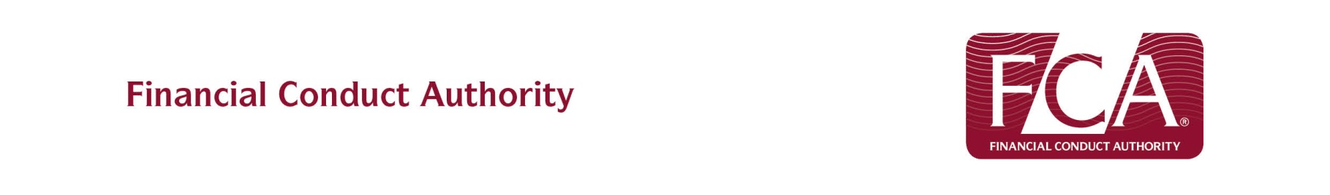
Suspicious Transaction Reporting Form
Please note this form is for the use of PRA or FCA Authorised firms only.

Description of the transaction (s)
Please include details of the financial instrument(s), including the ISIN code of the instrument; the market(s) concerned; the original order’s entry date/time, price and size; the times and sizes of the transaction(s); the type and characteristics of the order, etc

Reasons for suspecting that the transaction(s) might constitute insider dealing/market manipulation

Identities of persons carrying out transaction(s)
Names, address, telephone number, date of birth, account number, client identification code used by the firm, etc

Identities of any other persons known to be involved in the transaction(s)
Names, address, telephone number, date of birth, relation to person carrying out transaction; position held, role played, etc

Capacity in which the person performing the transaction(s) acts
e.g. broker, underwriter, agent

Further information which may be of significance (please list any accompanying material you are supplying)

Details of the person making notification

Name of person making notification -
Position in Firm -

Email Address -
Telephone Number -

Name of Firm -
Firm Reference Number of submitting firm -

Please email the completed form to market.abuse@fca.org.uk

