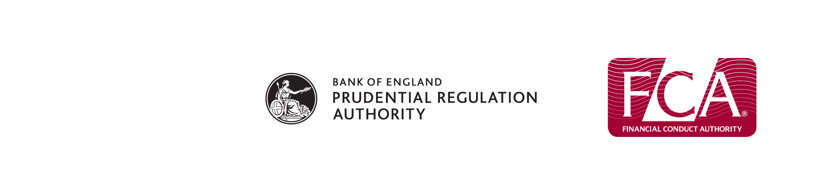
Mutual Societies Application Form
Mutual Societies Application Form
Alteration of Rules and/or Memorandum
Form

Alteration of Rules and/or Memorandum
Form
Full name of society:

Important information you should read before completing this form
We require building societies and societies registered under the Friendly Societies Act 1992 to complete this form if they are altering any of their rules either by a partial or complete alteration (by complete we mean the substitution of a new rule book in place of the existing rule book) or altering their memorandum either by a partial or complete alteration.
You must not use this form if your society is:
- an industrial and provident society;
- a credit union;
- a society registered under the Friendly Societies Act 1974; or
- a branch registered under the Friendly Societies Act 1974.
Please keep a copy of the form and the supporting documents for future reference.
The notes that accompany this form will help you complete the questions.
Please be aware any personal details you give on the form will be placed on the society's public file.
It is important you provide accurate and complete information and disclose all relevant information. If you do not, it may take us longer to assess your application.
Terms in this form
'FCA',’PRA’, 'us' and 'we' refer to the Financial Conduct Authority or Prudential Regulation Authority.
'You' refers to the person signing the form on behalf of the society.
Contents of this form
1 Details of Changes 3
2 Alteration of Rules 4
3 Alteration to the Memorandum 5
4 Statutory Declaration 6

Mutual Societies Application Form
Mutual Societies Application Form
Alteration of Rules and/or Memorandum
Form

Alteration of Rules and/or Memorandum
Form
Filling in the form
1 If you are using your computer to complete the form:
- use the TAB key to move from question to question and press SHIFT TAB to move back to the previous question; and
- print out the completed form and arrange for it to be signed in sections 2 and/or 3 and 4.
2 If you are filling in the form by hand:
- use black ink;
- write clearly; and
- arrange for it to be signed in sections 2 and/or 3 and 4.
3 If you make a mistake, cross it out and initial the changes; do not use correction fluid.
4 If you:
- leave a question blank;
- do not get the form signed; or
- do not attach the required supporting information
without telling us why, we will have to treat the application as incomplete. This will increase the time taken to assess your application.
5 If there is not enough space on the form, you may need to use separate sheets of paper. Clearly mark each separate sheet of paper with the relevant question number. Any separate sheets should be signed by the signatory to the form.
6 Post the form and supporting documents to us at:-
Mutuals Team
Financial Conduct Authority
25 The North Colonnade
Canary Wharf
LONDON
E14 5HS

1 | Details of changes
Society details
1.1 Society details

Register number
Proposed changes
1.2 What are you applying to alter?
Alteration of Rules Complete sections 2 and 4
Alteration of Memorandum Complete sections 3 and 4
Alteration of Rules and Memorandum Complete sections 2,3 and 4

2 | Alteration of rules
Alteration of rules
2.1 Are you applying for a partial or complete alteration of rules?
PartialContinue to question 2.2
CompleteContinue to question 2.3
Partial alteration of rules
2.2 You must attach the following:
Three printed copies of the alteration of rules, set out as per the “Specimen Wording For a Partial Alteration” at the end of the Notes, each
signed by the secretary and each specifying the date
on which the alteration is intended to take effect. Attached
A printed copy of the existing set of rules, marked
to show where the alterations occur, and what
they are. Attached

Continue to question 2.5
Complete alteration of rules
2.3 Is your society a friendly society or a building society?
Building society You must complete appendix 1 Completed
Friendly society You must complete appendix 2 Completed
2.4 You must attach the following:
Three printed copies of the new rule books, each signed
by the secretary of the society and each specifying the date
when the alteration is intended to take effect and marked
'All previous rules rescinded'. Attached

Continue to question 2.5
Signature
2.5 The Secretary of the society must sign and date below.
Signature

Date | dd/mm/yy

3 | Alteration to the memorandum
Alteration to the memorandum
3.1 Are you applying for a partial or complete alteration of memorandum?
Partial
Complete – substitution of a new document in place of document already registered as the memorandum
3.2 You must attach the following:
Either three copies of the Partial Alteration (set out as per the Specimen at end of the Notes) or three new full Memorandums for a Complete Alteration, each signed by
the secretary and each specifying the date on which the
alteration is intended to take effect Attached
A printed copy of the society's current memorandum,
marked to show where and in what manner it has been
altered (except where the society is substituting a new
document in place of the document already registered
as the memorandum) Attached
Substitution of a new
document
Signature
3.3 The Secretary of the society must sign and date below.
Signature

Date | dd/mm/yy

4 | Statutory Declaration
4.1 The Secretary of the society must sign below
Please read the relevant declaration and sign below.
For building societies
I do solemnly and sincerely declare that the alteration of the rules of the society and/or an alteration to the purpose and/or powers specified in the memorandum of the society was effected by a resolution of the society passed as a special resolution on the date below and that the record of alteration which accompanies this declaration is a true record of the alteration.
And I make this solemn declaration conscientiously believing the same to be true, and by virtue of the provisions of the Statutory Declarations Act 1835.
For societies registered under the Friendly Societies Act 1992
I do solemnly and sincerely declare that an alteration of the rules of the society and/or the memorandum of the society was made by the society in the manner prescribed in its rules and that the record of alteration which accompanies this declaration is a true record of the alteration.
And I make this solemn declaration conscientiously believing the same to be true, and by virtue of the provisions of the Statutory Declarations Act 1835.

Date of resolution (for building societies only) | dd/mm/yy

Name

Signature

Date | dd/mm/yy

Declared before

a solicitor

a commissioner for oaths

notary public

justice of the peace
Name

Declared at

Signature

Date | dd/mm/yy

End of form

