Guidance on National Private Placement Regime (NPPR) Connect notifications.
- Introduction
Connect is the online system used to make NPPR notification. You should use connect to make an NPPR notification if you are any of the following:
- Full-scope UK AIFM marketing (under regulation 57): a third country AIF; or a UK or Gibraltar feeder AIF of a master AIF, where the master AIF is either a third country AIF or is managed by a third country AIFM.
- Small third country AIFM marketing an AIF (under regulation 58), irrespective of whether the AIF is a UK AIF, or a third country AIF.
- Above-threshold third country AIFM marketing an AIF (under regulation 59), irrespective of whether the AIF is a UK AIF, or a third country AIF.
A notification should be made in Connect to:
- Create a new NPPR Manager
- Add new funds, either standalone or new sub-funds to existing umbrellas, to an existing NPPR Manager
- Inform us of material changes to the NPPR Manager or the fund; and
- Cease marketing
The following website will provide more information about the NPPR:
https://www.fca.org.uk/firms/nppr
- Register for Connect
Anyone can register for connect and make an NPPR notification. A link to the Connect webpage can be found in the webpage above.
- NPPR Access Code
If you are adding a new fund to an existing NPPR Manager, submitting a material change or a cease marketing notification then you will need an NPPR Access Code in order to complete the Connect notification.
The NPPR Access Code is specific to each NPPR Manager.
An NPPR Access Code is issued by email when a notification for a new NPPR Manager is submitted in Connect. NPPR Managers who made their notification prior to September 2019 may not have an NPPR Access Code and can call our contact centre on 0300 500 0597 from the UK, or +44 207 066 1000 from abroad to receive a code.
Please note that, for security reasons, we can only issue an NPPR Access Code to an email address at the NPPR Manager. We cannot issue codes to third parties representing an NPPR Manager.
If you lose your NPPR Access Code you can request a new one by calling our contact centre.
- Completing NPPR notifications in Connect
The notification will guide you through each section with the information required for each field. We have set out some additional guidance on the areas below where we see input errors.
  - Outcome selector – selecting a regulation
The outcome selector screen will show after you have selected either a new notification or a material change. You will need to select the correct Regulation that applies to your firm. If you are an existing NPPR Manager and select the wrong Regulation you will not be able to proceed with the rest of the notification.
If you are not sure which regulation to select then please refer to FUND 10.5 in the FCA Handbook: https://www.handbook.fca.org.uk/handbook/FUND/10/?view=chapter
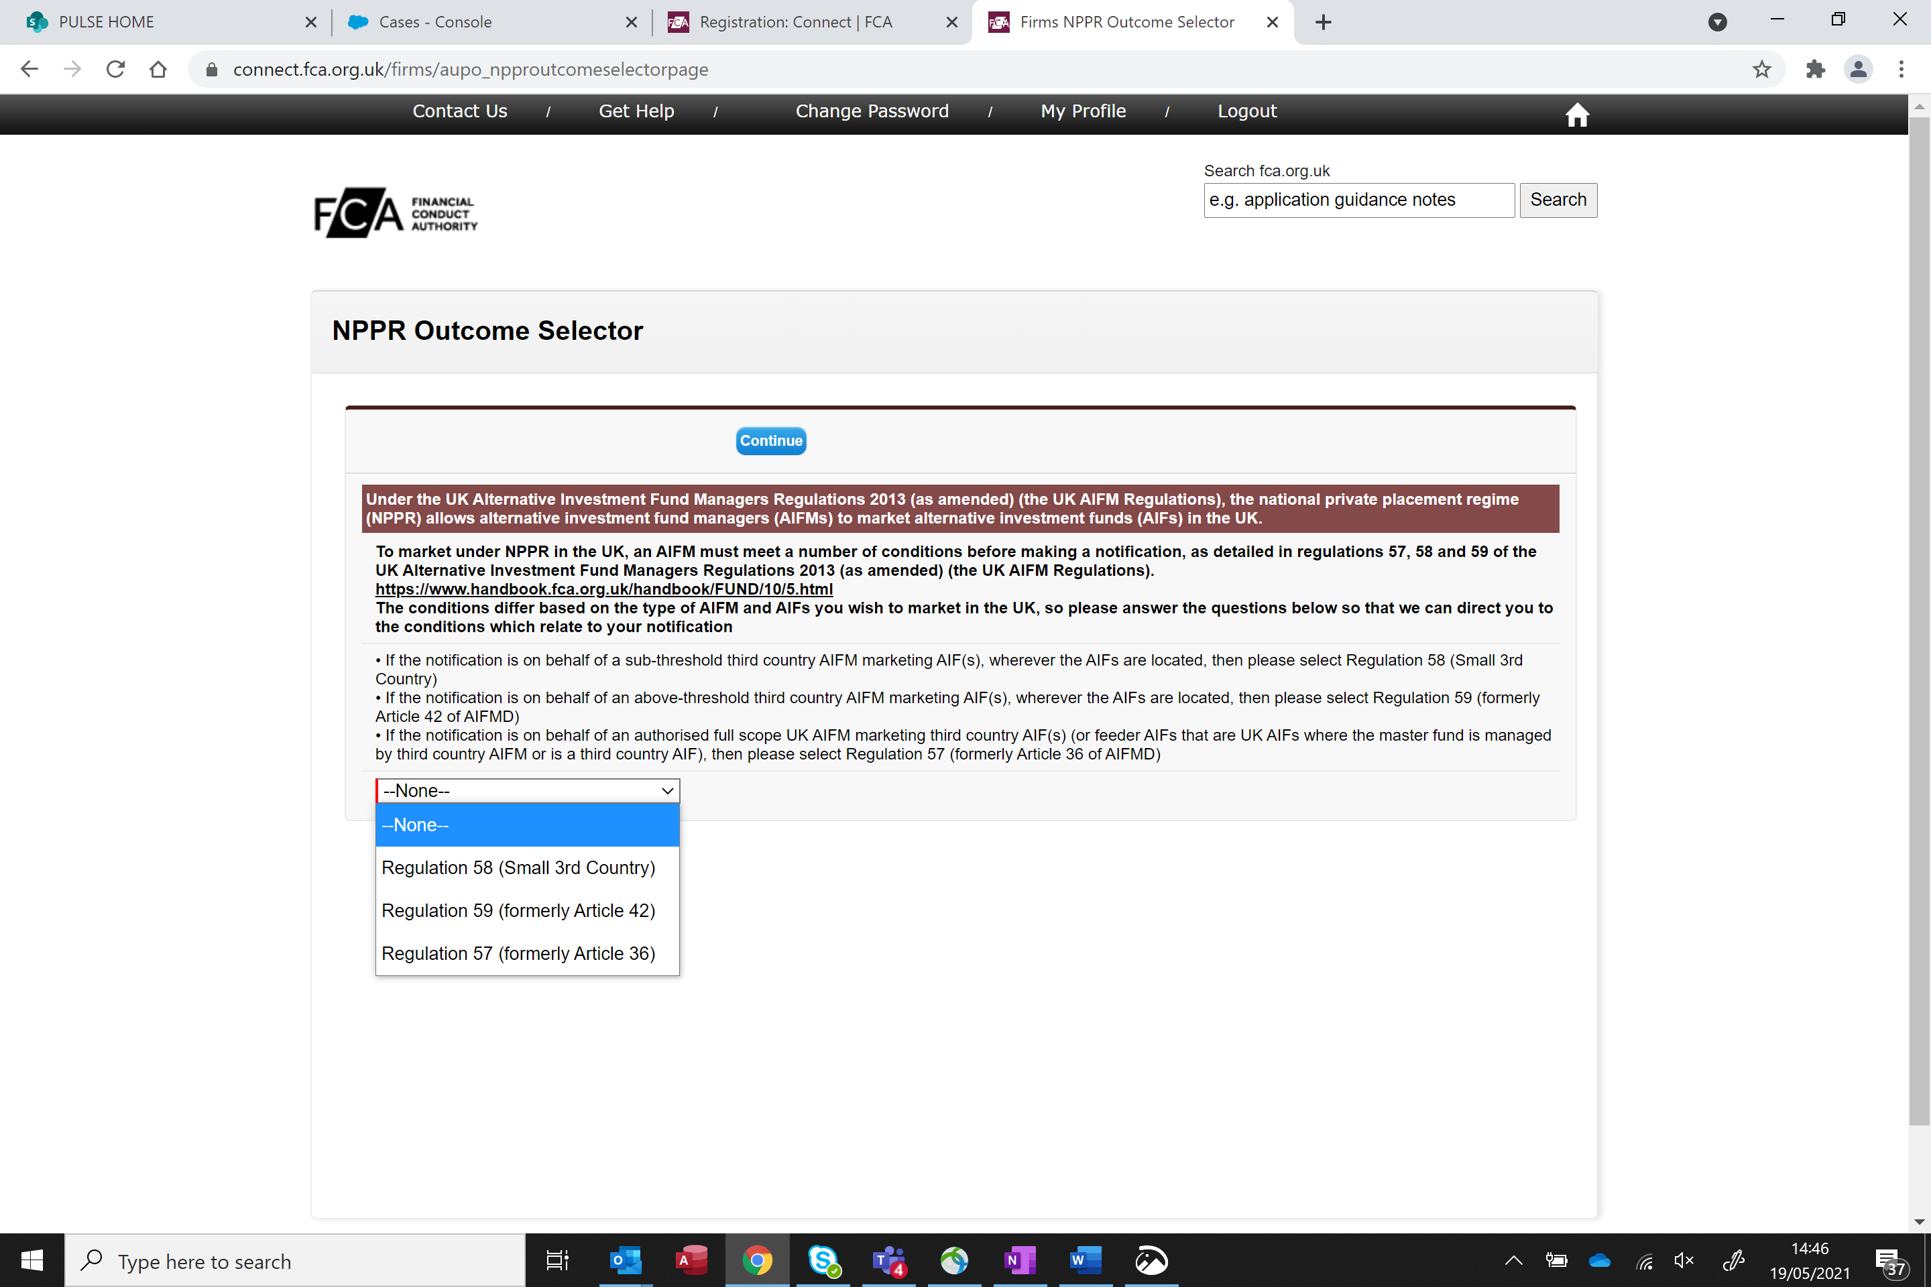

  - Firm check and existing NPPR Managers
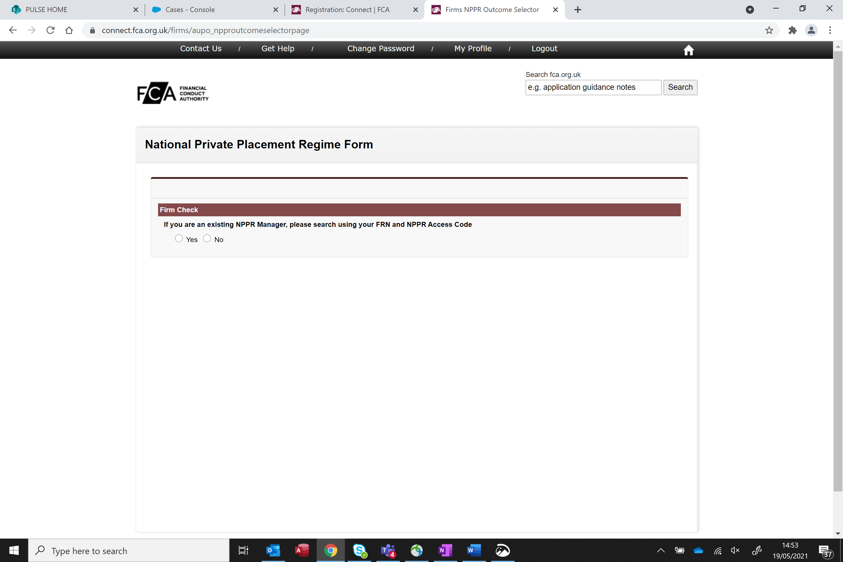
If you are an existing NPPR Manager you must select ‘yes’ and provide the FRN associated with your NPPR Manager record. If you continue as a new NPPR Manager this will create a duplicate NPPR Manager record. This will result in the creation of a new NPPR Manager record with a new Firm Reference Number (FRN) which will cause issues with RegData reporting and additional periodic fees for each NPPR Manager incorrectly created.
If you have forgotten your FRN or NPPR Access code then please contact us.
- Information on new fund
You will be asked to provide the following information
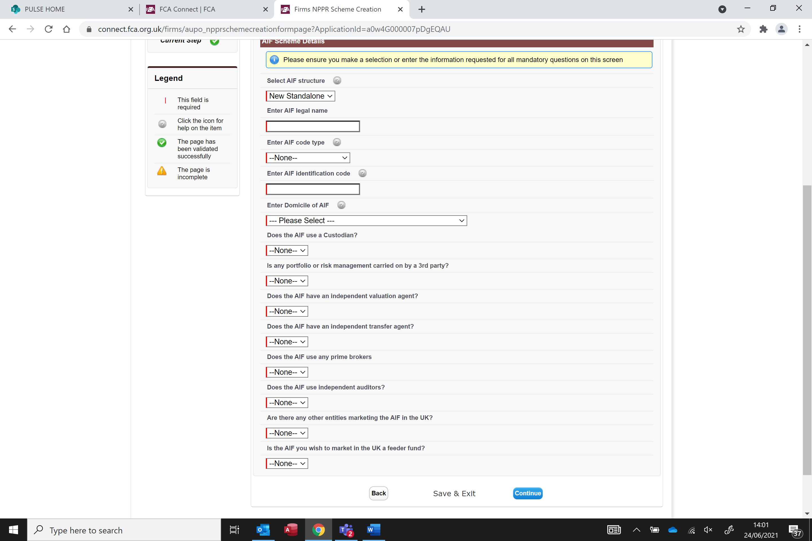
If you are not sure if the fund relationships with any of the third parties mentioned above then it is better to provide the information if you are unsure. The fields can remain blank if there is no information to be provided.

- Payment
Depending on the type of regulation being notified, there is a payment for each new standalone or umbrella. There is no additional fee for new sub-funds added to an umbrella.
The payment facility is built into the connect notification and you will need to enter card details to submit the notification.
Do not also make a bank transfer as this will result in a duplicate payment.

