Application for Authorisation
Fees and levies supplement – Wholesale firms
Full name of applicant firm

Important information you should read before completing this form
The notes that accompany this supplement will help you complete the questions. They also explain why we require the information we ask you for.

For further help on this supplement, please refer to the notes and to the rules at www.handbook.fca.org.uk/handbook/FEES/4/Annex1A.html (FEES 4 Annex 1A)

Monetary figures should be denominated in whole GBP. If the answer is 'nil' then you must write 'nil' – please do not leave it blank. Take care to be as accurate as possible - a poor estimate or forecast is unlikely to be grounds to revise fees at a later stage.

Purpose of this form
We require this information so we can calculate the applicant firm's FCA fees. We will also use this information to calculate the levies for the Money Advice Service (MAS), the Financial Ombudsman Service (FOS) and, where relevant, the levy for the Financial Services Compensation Scheme (FSCS).
The applicant firm's permissions at the time that it is granted authorisation will determine the fee-blocks to which it is allocated. The FCA periodic fees and levies for the first year following an applicant firm’s authorisation are based on the tariff data provided in this supplement. For firms who obtain their authorisation between 1 January and 31 March, the data provided here will also be used for the next fee-year.

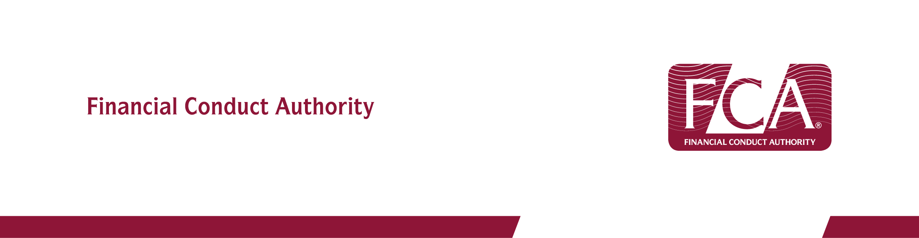

Fees and levies - Wholesale firms

FCA fees

1.1 Fee block A.7 – Portfolio Managers

How much total funds under management does the applicant firm estimate it will have at the end of the first year of authorisation?
Amount | £

Confirm amount in words

1.2 Fee block A.9 – Managers and depositaries of investment funds, and operators of collective investment schemes or pension schemes

How much total gross income does the applicant firm estimate from the activities relating to fee block A.9 for the first year of authorisation?
Amount | £

Confirm amount in words

1.3 Fee block A.10 – Firms dealing as principal

How many traders does the applicant firm estimate in the first year of authorisation?

Number

Confirm number in words

1.4 FCA Fee Block A.13 – Advisers / Arrangers

How much annual income does the applicant firm estimate for the first year of authorisation in relation to the regulated activities for fee-block A.13 (see FEES 4 Annex 1R, Part 1) i.e. advisors, arrangers, dealers or brokers?

Please exclude income arising from corporate finance business. This should be declared in fee block A.14.
Amount | £

Confirm amount in words

1.5 FCA Fee Block A.14 – Corporate finance advisers

How much annual income does the applicant firm estimate for the first year of authorisation in relation to the regulated activities for fee-block A.14 (see FEES 4 Annex 1R, Part 1) i.e. corporate finance business?
Amount | £

Confirm amount in words

1.6 Fee block A.21 – Firms holding client money or assets, or both

What is the highest value of client money and/or safe custody assets the applicant firm expects to hold during the first year of authorisation?

Client money
Amount | £

Confirm amount in words

Client assets
Amount | £

Confirm amount in words

The Financial Ombudsman Service general levy

For the purposes of the Financial Ombudsman Service general levy, a firm will fall into one or more industry blocks depending on its FCA permission. Data should include only business that is done with eligible complainants who are consumers. As a result, the data reported under the Financial Ombudsman Service general levy can be lower than that reported under the FCA fees section. If the applicant firm will not conduct any business with eligible complainants, it may apply for an exemption.

1.7 Fee block I005 – Portfolio Managers

How much relevant funds under management does the applicant firm estimate it will have at the end of the first year of authorisation?
Amount | £

Confirm amount in words

1.8 Fee block I006 – Managers and depositaries of investment funds, and operators of collective investment schemes or pension schemes

How much relevant gross income does the applicant firm estimate for the first year of authorisation?
Amount | £

Confirm number in words

1.9 Fee block I007 – Dealers as Principal

How many relevant traders does the applicant firm estimate in the first year of authorisation?

Number

Confirm number in words

1.10 Fee blocks I008/I009 – Advisory, Arrangers, Dealers or Brokers

How much relevant annual income does the applicant firm estimate for the first year of authorisation in relation to advisors, arrangers, dealers or brokers:
- holding and/or controlling client money/assets (I008); or
- not holding or controlling client money/assets (I009)?

Please exclude income from corporate finance business.
Amount | £

Confirm amount in words

1.11 Fee block I010 – Corporate finance advisers

How much annual income does the applicant firm estimate for the first year of authorisation in relation to the regulated activities for fee-block I010 - corporate finance business?
Amount | £

Confirm amount in words

Financial Services Compensation Scheme (FSCS) levy

The FSCS levy covers business that could give rise to a protected claim from an eligible claimant. As a result, the data reported under the FSCS levy can be different to that reported under the FCA fee. If the applicant firm does not conduct any business that could give rise to a protected claim from an eligible claimant it may apply for FSCS exemption.

Newly authorised firms do not contribute towards the FSCS specific and compensation costs in the first fee year. We will only use the information here for calculating FSCS levy in the second fee year where a firm obtains authorisation between 1 January and 31 March.

1.12 FSCS class SC02 – Life and Pensions Intermediation

How much annual eligible income does the applicant firm estimate for the first year of authorisation in relation to its life and pensions intermediation (including pure protection) business only?
Amount | £

Confirm amount in words

1.13 FSCS class SD01 – Investment provision

How much annual eligible income does the applicant firm estimate for the first year of authorisation in relation to investment provision business only?
Amount | £

Confirm amount in words

1.14 FSCS class SD02 – Investment Intermediation

How much annual eligible income does the applicant firm estimate for the first year of authorisation in relation to investment intermediation business only?
Amount | £

Confirm amount in words

Declaration of ongoing FCA fees liability

1.15 You must confirm that the applicant firm understands that it is liable and remains liable to pay fees until such time as the FCA cancels its permission. This is irrespective of whether it is trading, or even if it has notified us of intention to cease trading or submitted an application to cancel.

Yes

Declaration of FSCS and the Financial Ombudsman Service exemption

Please note that if the applicant firm conducts business with private individuals then exemption is unlikely to be available. This is because private individuals are likely to qualify as eligible FSCS claimants and/or FOS complainants.

1.16 The Financial Ombudsman Service exemption – if the applicant firm will not carry on business with eligible complainants and does not foresee doing so in the immediate future, please tick the box below.

Applicant firm is exempt from the Financial Ombudsman Service

1.17 FSCS Exemption – if the applicant firm will not carry on business that could give rise to a protected claim by an eligible claimant and does not foresee doing so in the immediate future, please tick the box below.

Applicant firm is FSCS exempt

