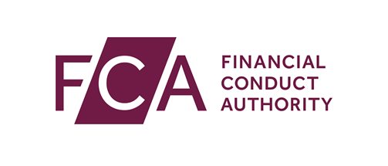

National Storage Mechanism – Template for authorisation letter to be used for individuals seeking approval from the FCA to upload/file information

[Date]

Dear National Storage Mechanism Administrator,

I, [Name of 1st Officer], with [Name of 2nd Officer] of [Issuer Name], with offices located at [Issuer Address] certify that [Name of Submitter(s)] with email(s) [Email Address(es)] is/are authorised to submit documentation to the National Storage Mechanism on its behalf.

[Issuer Name], will advise the FCA of any change to the status of the authorisation granted herein.

Sincerely,

[Name and Signature of 1st Officer]  [Position]  [Email Address and Telephone Number] | [Name and Signature of 2nd Officer]  [Position]  [Email Address and Telephone Number]

Completion notes
A letter is required for each issuer you want to submit on behalf of, even if you are an employee or representative of the issuer.
All fields in square brackets must be completed.
Two signatories are required. Signatories need to be a Partner, President, Treasurer, Corporate Secretary, or Director of the issuer you want to upload on behalf of.
The authorisation letter should be presented on letterheaded paper from the issuer you want to upload on behalf of.
The letter needs to be uploaded via an appropriate case on the FCA’s Electronic Submission System, unless otherwise directed by the FCA.

